50%

**d_rmax** = 0.001012724476311684

(601,)

**Averages and Variances**

< E > = 103586.31831183321

< V > = 103584.47331183321 < Delta V^2 > = 1045201.4049290934

< K > = 1.845

< T > = 1.23

< P > = -250455.66434422345 < Delta P^2 > = 6030192.041267464

< PV > = -25945828609.87947 < Delta P Delta V > = -2510530.817802429

< PK > = -462090.70071509224

**Thermodynamic Quantities**

C_V,m/R = 345429773.7681914

beta_T = -8.160785923291108e-11

gamma_V = -1659416.0322707577

PV/NkT = -1018112.4566838351

alpha = 0.00013542138997038784

Maximum change in distance

0.001012724476311684

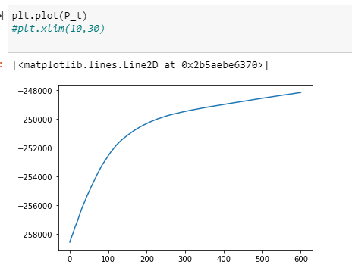

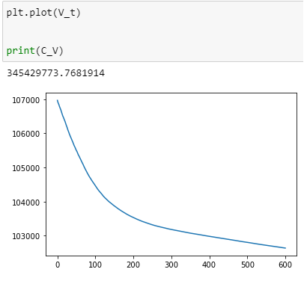

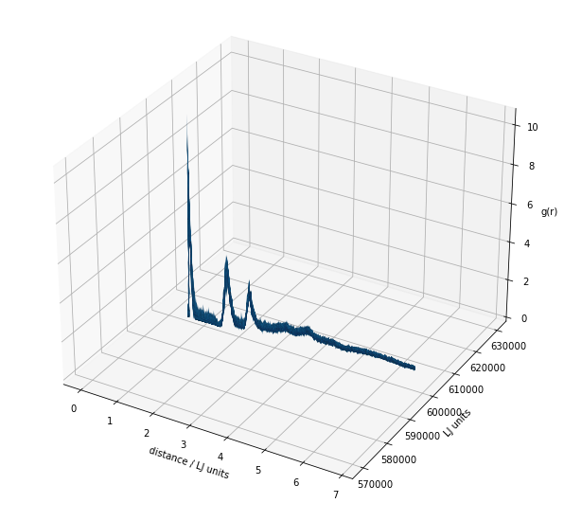

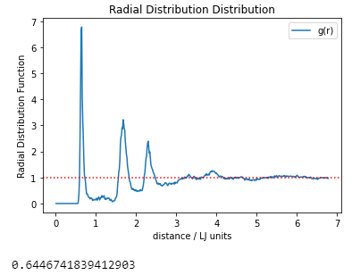

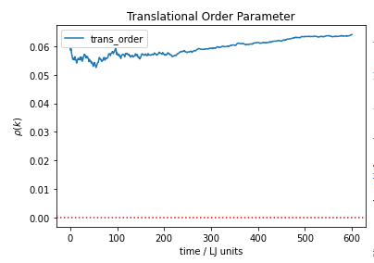

20%

**d_rmax** = 0.039

**Averages and Variances**

< E > = 14.551602995047778

< V > = 12.706602995047778 < Delta V^2 > = 0.19736080233493114

< K > = 1.845

< T > = 1.23

< P > = -73.06976981119352 < Delta P^2 > = 1.2150612267998353

< PV > = -928.9570369536949 < Delta P Delta V > = -0.4884810233315875

< PK > = -134.81372530165206

**Thermodynamic Quantities**

C_V,m/R = 66.72599059254782

beta_T = -0.0007113399356116056

gamma_V = -0.12287727102358881

PV/NkT = -297.03158459834765

alpha = 8.740751005804948e-05

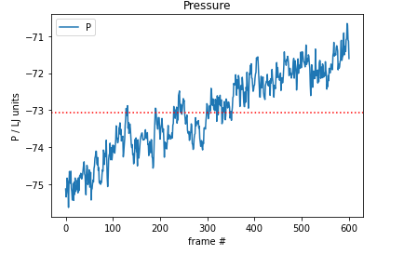

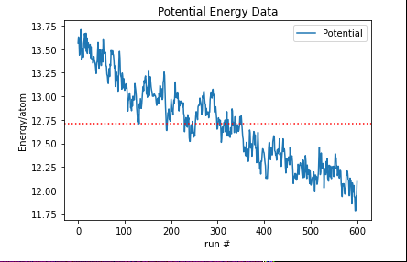

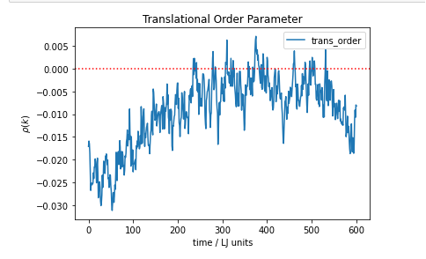

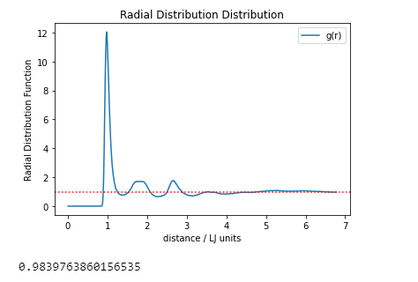

5%

**d_rmax** = 0.04

**Averages and Variances**

< E > = 14.33056414733718

< V > = 12.485564147337179 < Delta V^2 > = 0.2339734871214133

< K > = 1.845

< T > = 1.23

< P > = -72.57753132395067 < Delta P^2 > = 1.3284009737764502

< PV > = -906.7269018339476 < Delta P Delta V > = -0.5554788333881788

< PK > = -133.90554529268897

**Thermodynamic Quantities**

C_V,m/R = 78.82615741999251

beta_T = -0.0006092552932633127

gamma_V = -0.16716163222167946

PV/NkT = -295.03061513801083

alpha = 0.00010184410926159334

